
(Affilated to Tribhuvan University)
Kathmandu, Nepal

COMPILER DESIGN PRACTICAL
B.SC.CSIT

Submitted By:
Sagar Giri
Roll No:0205

Submitted To:
Satya Maharjan

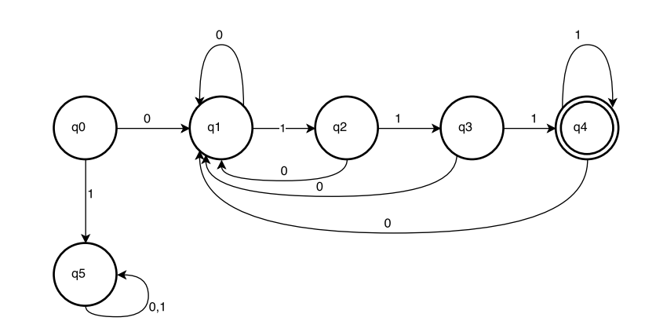DFA that accepts the String that starts with 0 and end with 111.

PseudoCode:

Store the predefined accepting states in a dictionary map
Take input from the user.
Check whether the string is accepted or not.
Start the loop from i=1 to length(input)
Set current state to q0
Get value from Map as current state and input.
Set the next state to the current state
end loop
Check if current state is q4 or not
if yes:
String is accepted.
else:
String is rejected
Print the DFA.

Program Coding:

checkStrings.py

import dfaStates
def check(inp):
flag = False
if(inp[0]=='0'):
temp = inp[-3:]
for each in temp:
if each == '1':
flag = True
else:
flag = False
return
return flag

print("PROGRAM TO CHECK A STRING STARTING WITH '0' & ENDING WITH '111'")
print '*'*60
print("Enter a string to check")
inp = str(raw_input())
flag = check(inp)
if(flag):
print("Correct")
dfaStates.printDFA(inp, flag)
else:
print("Incorrect")
dfaStates.printDFA(inp, flag)

dfaStates.py
def printDFA(inp, flag):
dfa = ""
transZero = {"q0":"q1",
"q1":"q1",
"q2":"q1",
"q3":"q1",
"q4":"q1",
"q5":"q5"}
transOne = {"q0":"q5",
"q1":"q2",
"q2":"q3",
"q3":"q4",
"q4":"q4",
"q5":"q5"}
dfa = dfa + "q0-->"
currentState = "q0"
for i in range(0,len(inp)):
if inp[i] == '0':
currentState = transZero[currentState]
dfa = dfa + currentState + "-->"
elif inp[i] == '1':
currentState = transOne[currentState]
dfa = dfa + currentState + "-->"
else:
currentState = "wrong"
if currentState == "q4":
print dfa+"Accepts"
else:
print dfa+"Rejects"

Output:
